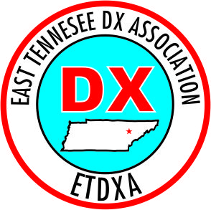
East Tennessee DX Association
May 20, 2024

CALL CQ -.-. --.- THAT’s WHAT WE DO!

The May meeting of East Tennessee DX Association (ETDXA) was held on 5/20/24. Our President Tim Berarducci, AJ4HW, called the meeting to order at 1830 hours.

Attendance:
Members in-person: 14 Members on Zoom: 3
Guests in person: 1 Guests on Zoom: 6
Total attendance: 24
Note: The names of 4 Zoom attendees were missed. Apologies from Tony.

Health and Welfare: No word on Don Prater’s current condition.

Old Business:The ongoing important need for a Vice-President was emphasized by Tim, AJ4HW.

Treasurer’s Report: There are sufficient funds in the treasury to support future DXPeditions.

New Business: Nothing discussed.

DX Report: Mike, N4MIK, reported two upcoming DXPeditions, Glorioso and West Malaysia. Also, ARRL Digital Contest (6/1) and CQ WW WPX Contest (5/25) are coming up. Lots of DX is out there. Super Fox & Hound from Joe Taylor coming out soon for Beta testing.

Hamfest: The Knoxville Hamfest will be June 15 at Wallace Memorial Baptist Church at 701 Merchant Drive.

Program: A very informative presentation was given by Dudley Pitts, KM4IYQ, ARRL Club Coordinator for East TN, Delta Division; and Dale Darling, W9WBA, ARRL Section Manager, middle TN. Dudley reported very interesting statistics.
- There are 28 ARRL affiliated clubs in East TN.
- There are 679,884 licensed hams in the US, 48% of which are Technician class.
- There are 170,000+ ARRL members in the US.
- By comparison, there are 1,300,000 hams in Japan.
- There are 2,664 hams in Knoxville, 1,987 in Nashville, and 1,483 in Memphis.
- In Tennessee, there are 9,327 Tech Class, 5,219 General and 4,430 Extra Class.
- The ARRL represents and benefits all ham radio operators, not just ARRL members. Efforts are being made to increase league membership.
Dale Shared many interesting stories from his 72 year career in Ham Radio.

Door Prize: There was no drawing for a door prize.

There being no further business the meeting was adjourned at 1945 hours.

Respectfully submitted,

Tony DiGeorge, KU4NY
Secretary/Treasurer

